TaskFlow API — Docker Muhitini Sozlash: Muammolar va Yechimlar
Loyiha: TaskFlow API (Middle D o'quv loyihasi)
Sana: 2026-yil 7-oktabr
TaskFlow API loyihasini qurishdan maqsad — Middle D darajasidagi texnologiyalarni amalda o'rganish. Maqsad: bir loyiha ichida RabbitMQ, Docker, SignalR, Hangfire, MinIO, IMemoryCache va NSubstitute texnologiyalarini birga ishlatib ko'rish.

Loyiha uchun to'rtta servis docker orqali ishga tushirildi: PostgreSQL, RabbitMQ, MinIO va API o'zi.

docker-compose.yml
services:
postgres:
image: postgres:15
container_name: taskflow_postgres
environment:
POSTGRES_DB: taskflow_db
POSTGRES_USER: taskflow_user
POSTGRES_PASSWORD: taskflow_pass
ports:
- "5433:5432"
volumes:
- postgres_data:/var/lib/postgresql/data
networks:
- taskflow_network

rabbitmq:
image: rabbitmq:3-management
container_name: taskflow_rabbitmq
environment:
RABBITMQ_DEFAULT_USER: taskflow_user
RABBITMQ_DEFAULT_PASS: taskflow_pass
ports:
- "5672:5672"
- "15672:15672"
volumes:
- rabbitmq_data:/var/lib/rabbitmq
networks:
- taskflow_network

minio:
image: myminio:latest
container_name: taskflow_minio
command: server /data --console-address ":9001"
environment:
MINIO_ROOT_USER: taskflow_user
MINIO_ROOT_PASSWORD: taskflow_pass123
MINIO_VOLUMES: "/data"
ports:
- "9000:9000"
- "9001:9001"
volumes:
- minio_data:/data
networks:
- taskflow_network

volumes:
postgres_data:
rabbitmq_data:
minio_data:

networks:
taskflow_network:
driver: bridge

Muammo 1: minio/minio Docker Hub dan o'chirilgan
Xatolik xabari:
pull access denied for minio/minio, repository does not exist
or may require 'docker login'
Sababi:
MinIO Community Edition 2025-yil dekabrda maintenance modega o'tdi va 2026-yil sentabrda minio/minio hamda minio/mc repositorylari Docker Hub dan butunlay o'chirildi. Bu holat MinIO ning enterprise mahsulot — AIStor ga to'liq o'tishini bildiradi.
O'rganilgan narsa:
Docker image lari registrylarga bog'liq — kompaniya o'z image larini istalgan vaqt o'chirishi yoki ko'chirishi mumkin. Shuning uchun production muhitda image versiyalarini pin qilib qo'yish va o'zingizning private registry (masalan, Harbor, Nexus) ga nusxalab olish tavsiya etiladi.
Sinab ko'rilgan alternativlar:
Variant | Natija | Sababi
minio/minio | ❌ | Docker Hub dan o'chirilgan
quay.io/minio/minio | ❌ | 401 UNAUTHORIZED — login talab qiladi
quay.io/minio/aistor/minio:RELEASE.2026-09-19T17-05-25Z | ⚠️ | Pull bo'ldi, lekin enterprise license talab qildi
quay.io/minio/minio:RELEASE.2025-09-07T16-13-09Z | ❌ | 401 UNAUTHORIZED
bitnami/minio | ❌ | Tarmoq cheklovlari
Yakuniy yechim:
MinIO GitHub reposi (github.com/minio/minio) dan source kodni yuklab, Linux binary yasab, o'z Docker image imizni qurishdan iborat bo'ldi.

Ushbu URL orqali github manzildan repo yuklab olindi va lokal komyuterga minIo yuklandi: https://github.com/minio/minio

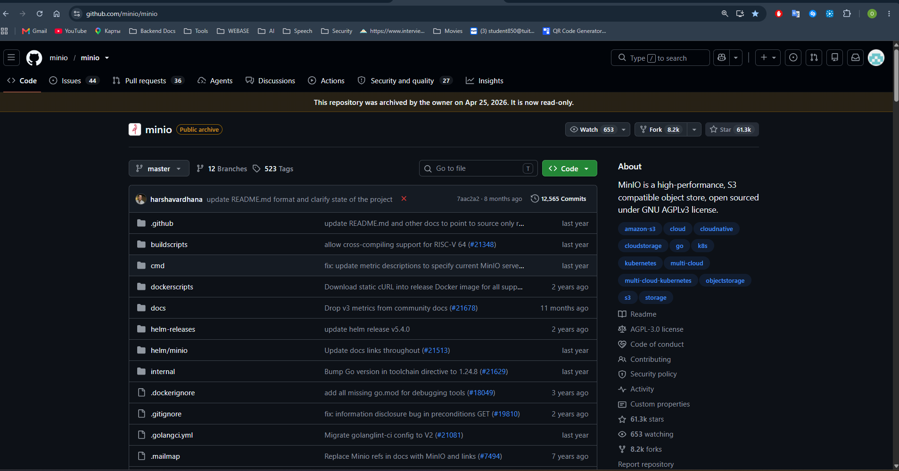

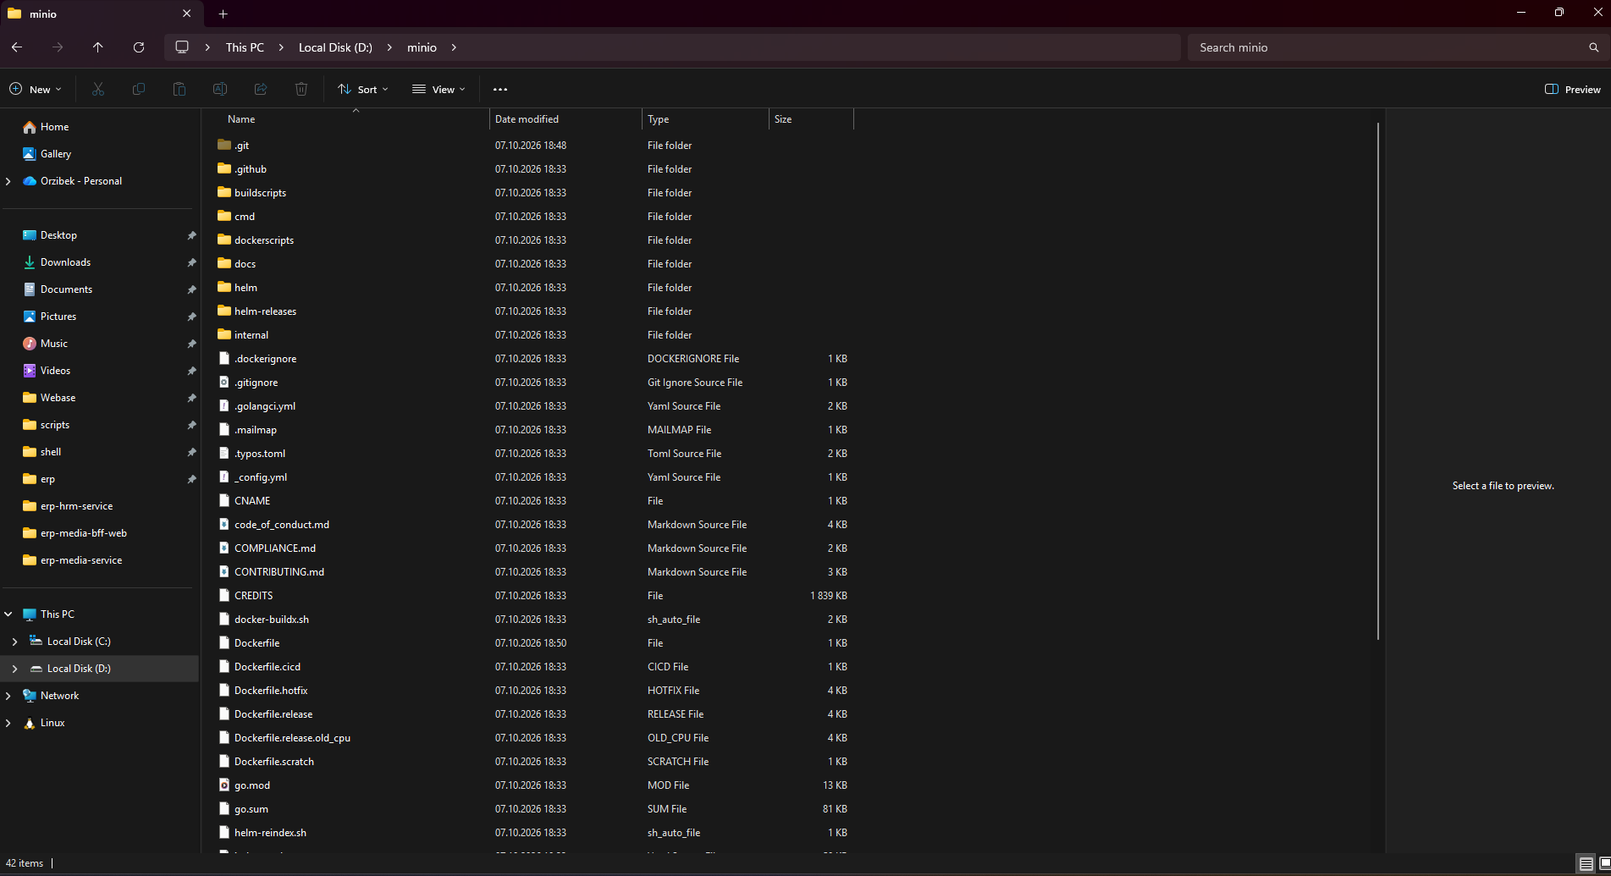

MinIO o’rnatib olingandan keyin avval docker orqali minioga lokal image yasab oldik va keyin docker-compose.yml fayldagi minio uchun image nomini “image: myminio:latest”qilib o’zgartirdik:
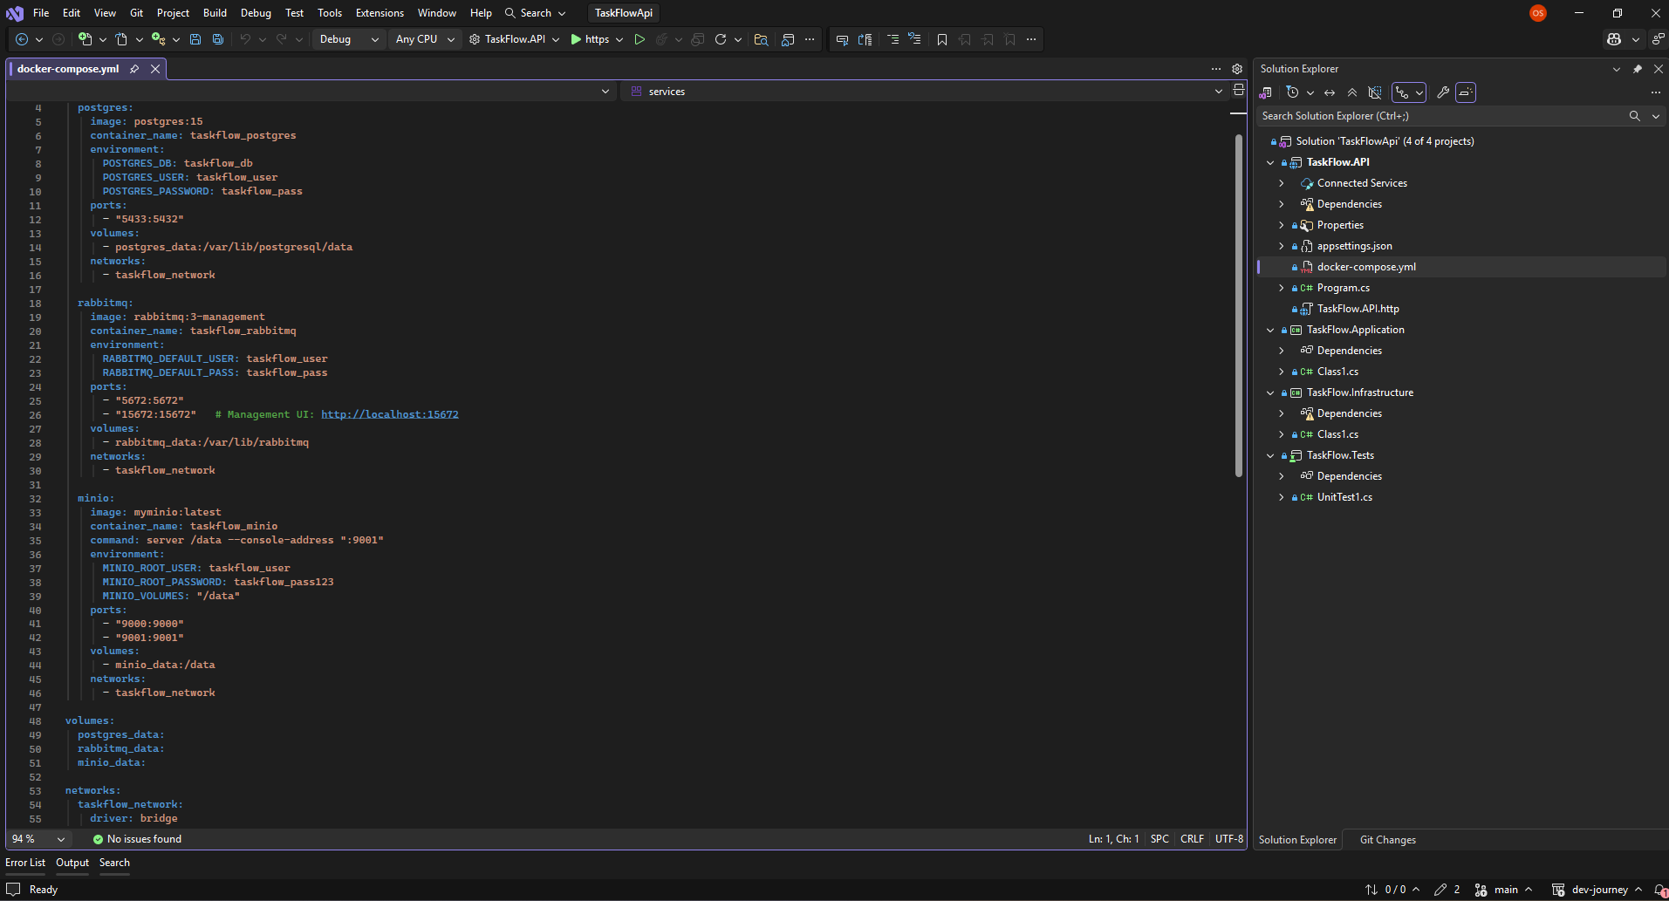

Keyin esa API loyiha joylashgan papka yo’lini terminalda ochib oldik va konteynerlarni ishga tushirdik, buyruq: docker-compose up -d
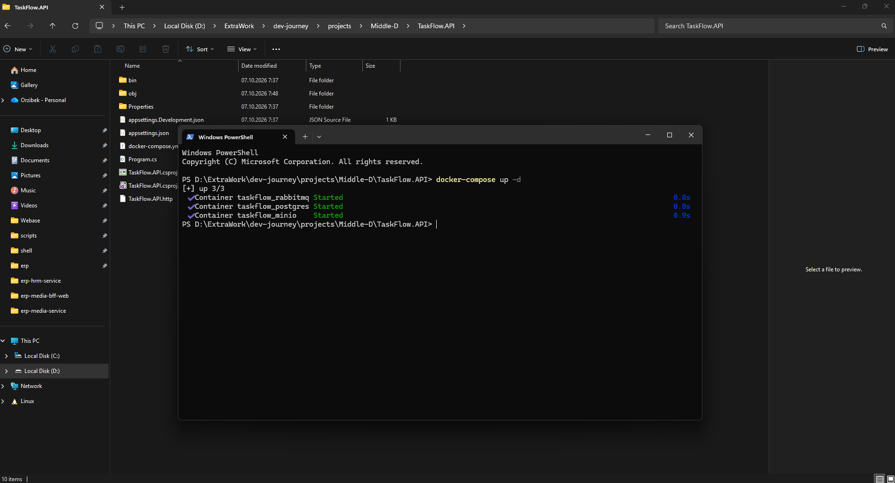

Hamma konteynerlar ishladi, RabbitMQ va MinIO uchun UI lar lokalhostda 15672 va 9001 portlarda ko’rinadi agar ishga tushgan bo’lsa:

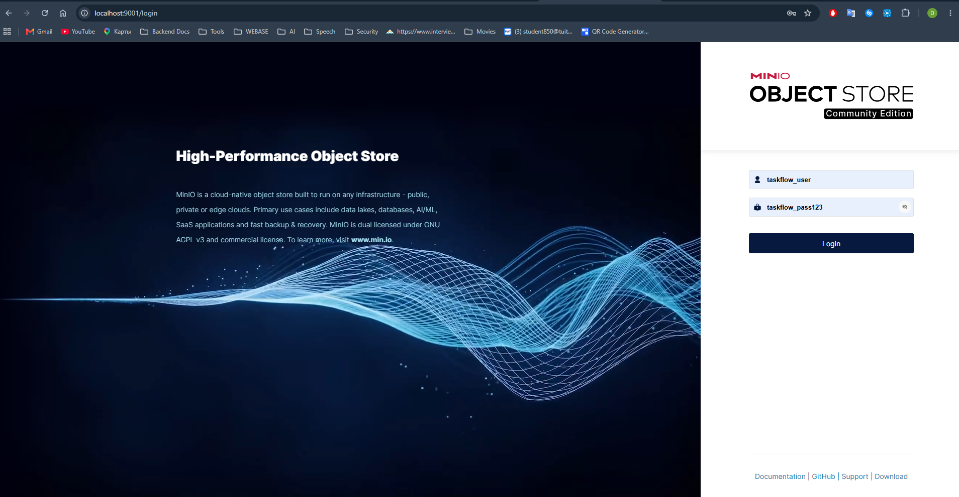
MinIO ochildi UI port 9001.

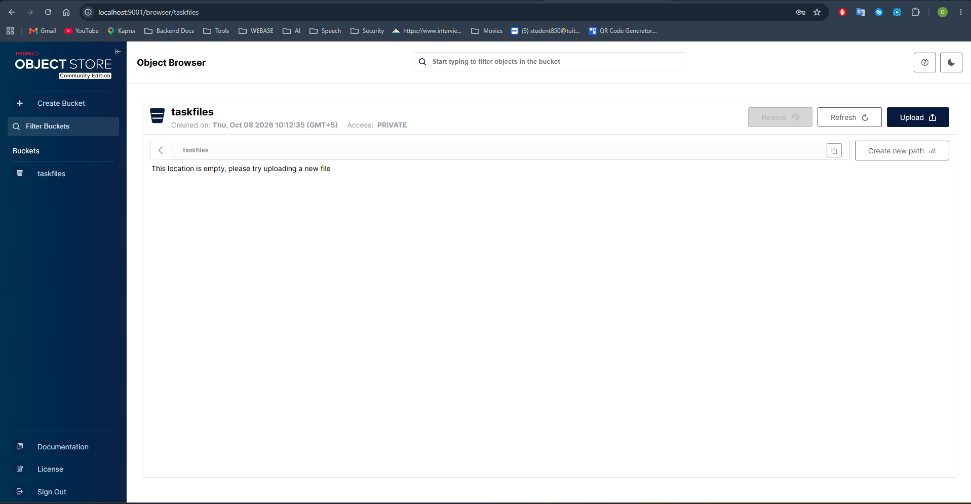
Login parol yml fayldagi bilan kirib oldim va bucket yaratib ko’rdim, hammasi joyida.

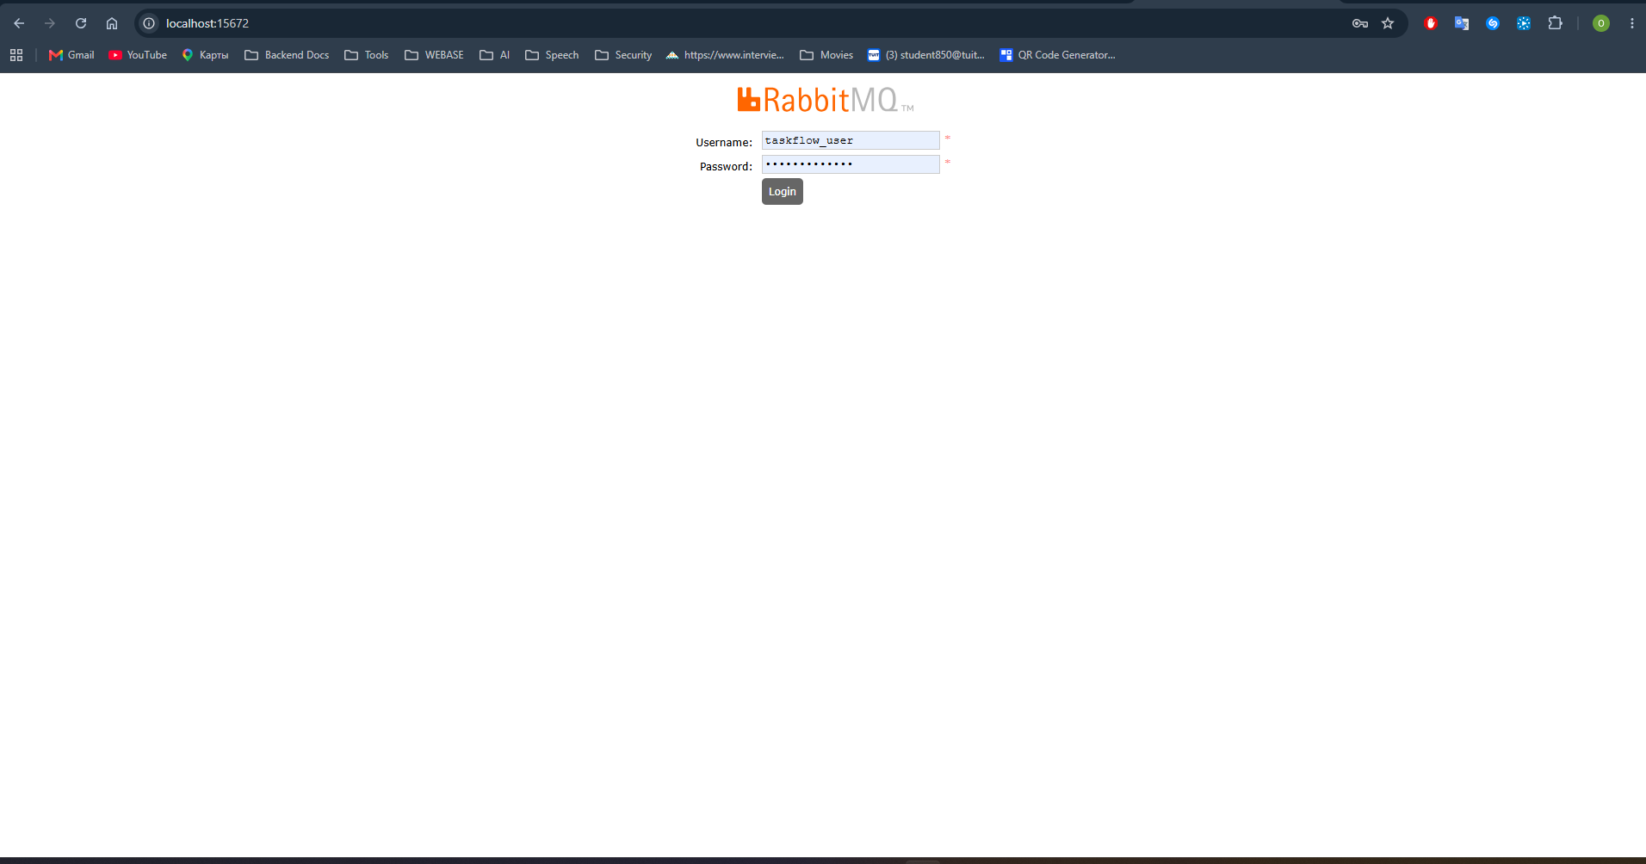

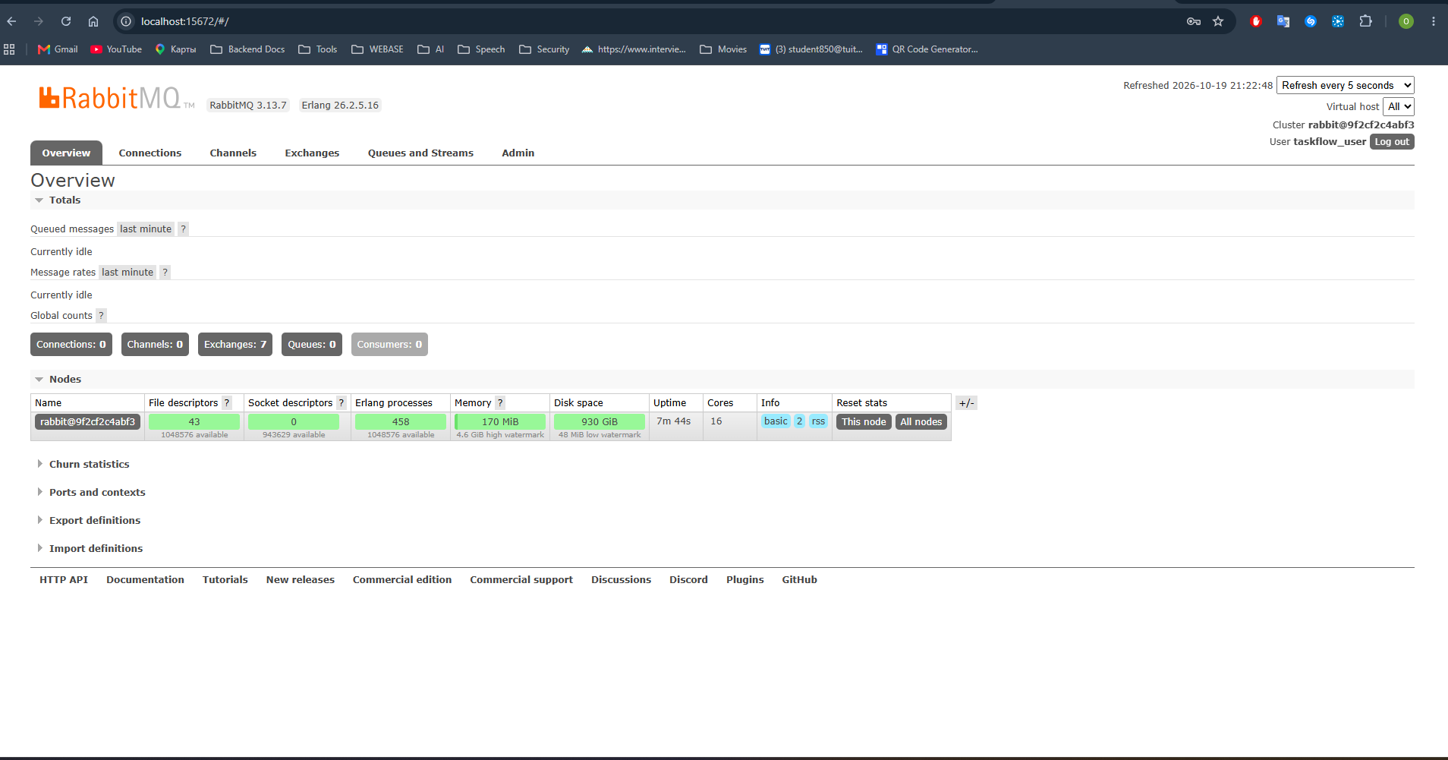

RabbitMQ ham run bo’lgan va login parollar orqali kirish ishlayapti.

Muammo 2: quay.io/minio/aistor/minio — License xatoligi
Xatolik xabari (brauzerda):
Invalid Login
Access denied. No license is installed.
Please install a valid license using 'mc license update' to enable service.

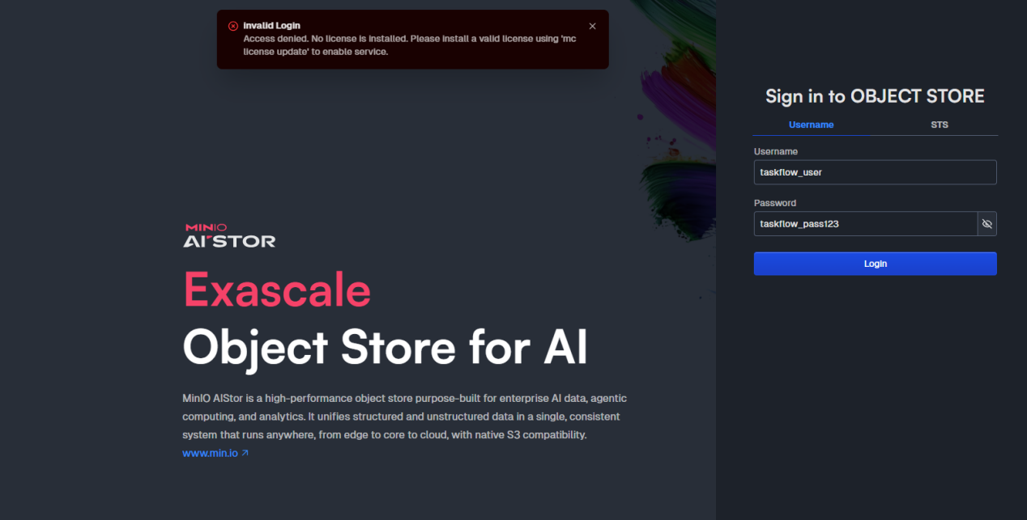
Sababi:
quay.io/minio/aistor/minio — bu MinIO AIStor, enterprise versiya. Bepul foydalanib bo'lmaydi, tijoriy litsenziya talab qiladi. Biz kerakli Community Edition emas edi.
O'rganilgan narsa:
Bir xil loyiha nomi ostida ham bepul, ham pullik versiyalar mavjud bo'lishi mumkin. Image nomiga e'tibor berish kerak: aistor so'zi enterprise ekanligini bildiradi.

Muammo 3: MinIO source dan Docker image yasash — FROM minio/minio:latest xatoligi
Xatolik xabari:
ERROR: failed to build: failed to solve: minio/minio:latest:
failed to resolve source metadata for docker.io/minio/minio:latest:
pull access denied
Sababi:
MinIO ning GitHub reposidagi Dockerfile o'zi ham FROM minio/minio:latest bilan boshlanadi — ya'ni Docker Hub dagi o'chirilgan imageni base sifatida ishlatadi. Bu Dockerfile ham endi ishlamaydi.
Yechim:
Eski Dockerfile ni o'chirib, o'zimiz yangi Dockerfile yozdik. Bu yerda muhim tushuncha: multi-stage build yoki scratch/distroless image dan foydalanish — binary faylni to'g'ridan-to'g'ri minimal Linux image ga joylash.
Yangi Dockerfile (o'zimiz yozgan):
FROM debian:bookworm-slim
RUN apt-get update && apt-get install -y \
ca-certificates \
&& rm -rf /var/lib/apt/lists/*
COPY minio /usr/local/bin/minio
RUN chmod +x /usr/local/bin/minio
EXPOSE 9000 9001
ENTRYPOINT ["/usr/local/bin/minio"]
O'rganilgan narsa:
Docker image yaratish uchun albatta boshqa image dan meros olish shart emas. debian:bookworm-slim kabi minimal base image yetarli. Muhimi — binary fayl to'g'ri arxitektura uchun (linux/amd64) build qilingan bo'lishi kerak.

Muammo 4: Windows da build qilingan binary Linux containerda ishlamaydi
Sababi:
go build -o minio.exe . buyrug'i Windows uchun .exe fayl yaratadi. Linux container esa Windows executable faylini bajara olmaydi — ikki xil operatsion tizim uchun ikki xil binary kerak.
Yechim — Cross-compilation:
Go tilining kuchli tomonlaridan biri — bir platformada boshqa platform uchun binary yasab berish imkoniyati (cross-compilation).
# Windows terminalida Linux uchun binary yasash$env:GOOS="linux"$env:GOARCH="amd64"
go build -o minio .
Bu yerda:
- GOOS=linux — maqsad operatsion tizim Linux
- GOARCH=amd64 — maqsad protsessor arxitekturasi x86-64
- -o minio — chiquvchi fayl nomi (.exe siz)
Natijada minio nomli Linux binary yaratildi va uni Docker image ga joylash mumkin bo'ldi.
O'rganilgan narsa:
Go dasturlash tili cross-compilation uchun kuchli qo'llab-quvvatlash beradi. GOOS va GOARCH muhit o'zgaruvchilari orqali istalgan platforma uchun binary yasash mumkin. Bu CI/CD pipeline larda juda foydali.

Muammo 5: Storage resources are insufficient — Erasure Coding xatoligi
Xatolik xabari (docker logs):
Error: Unable to initialize backend: Storage resources are insufficient
for the read operation .minio.sys/pool.bin, retrying in 1.9s
Sababi:
MinIO ning zamonaviy versiyalarida Erasure Coding mode default holda yoqilgan. Bu mode ma'lumotlarni bir nechta diskka bo'lib saqlaydi va kamida 4 ta disk (yoki 4 ta node) talab qiladi. Biz esa faqat bitta /data volume berdik.
Erasure Coding nima?
Ma'lumotlarni bir necha bo'lakka bo'lib, har birini alohida joyga saqlash usuli. Agar ba'zi disklar ishdan chiqsa ham, ma'lumotlarni tiklash mumkin. Production uchun juda foydali, lekin developerment muhiti uchun ortiqcha.
Yechim:
MINIO_VOLUMES environment variable ni aniq ko'rsatib, single-node rejimda ishlatish:
environment:
MINIO_VOLUMES: "/data"
Shuningdek, eski buzilgan volume ni tozalash kerak edi:
docker-compose down
docker volume rm taskflowapi_minio_data
docker-compose up -d
O'rganilgan narsa:
Docker volume lari persistent (doimiy) saqlashni ta'minlaydi — container o'chirilsa ham ma'lumot yo'qolmaydi. Lekin agar volume da noto'g'ri yoki buzilgan ma'lumot bo'lsa, uni qayta yaratish kerak. docker volume rm buyrug'i volumeni butunlay o'chiradi.

4. MinIO Image Yaratish — To'liq Jarayon

4.1 Go o'rnatish
MinIO source kodni compile qilish uchun Go 1.24+ kerak:
- go.dev/dl saytidan go1.24.x.windows-amd64.msi yuklab o'rnatdim
- Tekshirish: go version
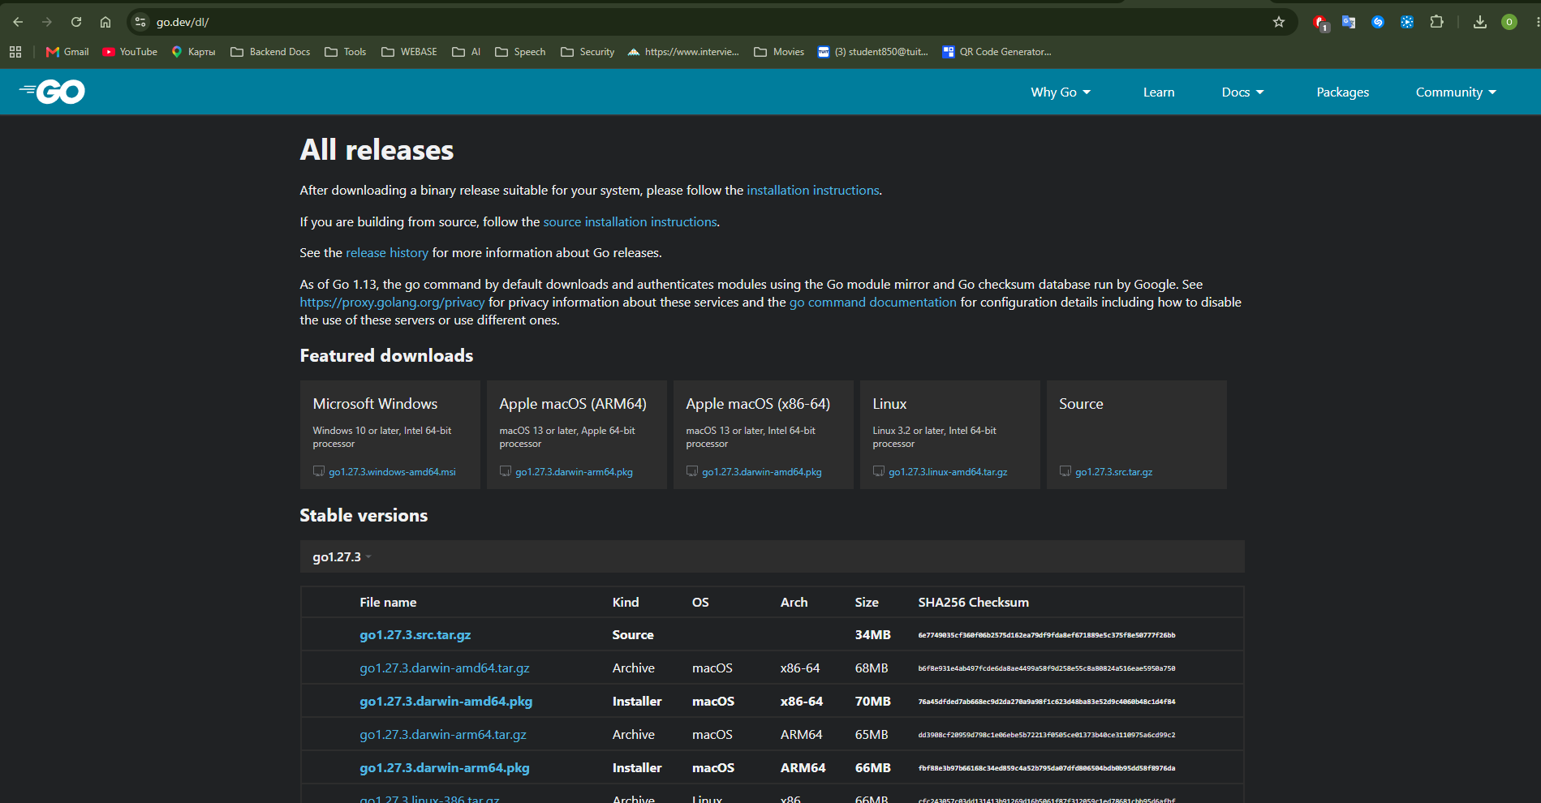
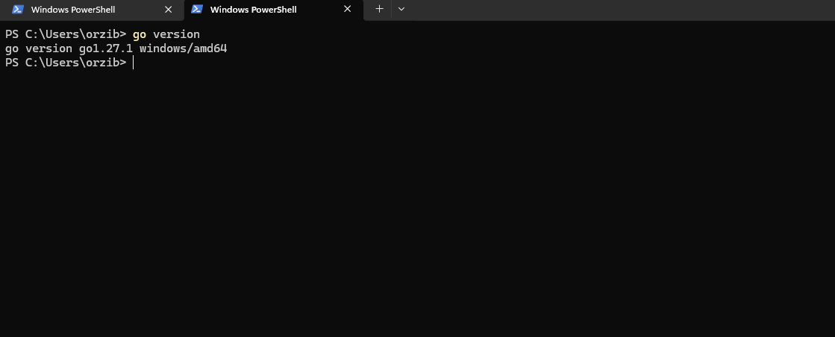

4.2 MinIO source kodni clone qildim
git clone https://github.com/minio/minio.git
cd minio

4.3 Linux binary yasash
$env:GOOS="linux"$env:GOARCH="amd64"
go build -o minio .
⚠️ Bu jarayon biroz vaqt oldi— MinIO katta loyiha.

4.4 Yangi Dockerfile yozish
D:\minio\Dockerfile faylini quyidagi matn bilan to'liq almashtirdim:
FROM debian:bookworm-slim
RUN apt-get update && apt-get install -y \
ca-certificates \
&& rm -rf /var/lib/apt/lists/*
COPY minio /usr/local/bin/minio
RUN chmod +x /usr/local/bin/minio
EXPOSE 9000 9001
ENTRYPOINT ["/usr/local/bin/minio"]

4.5 Docker image yasash
docker build -t myminio:latest .

5. Erishilgan Natija
[+] up 4/4
✔ Network taskflowapi_taskflow_network Created
✔ Container taskflow_rabbitmq Started
✔ Container taskflow_postgres Started
✔ Container taskflow_minio Started

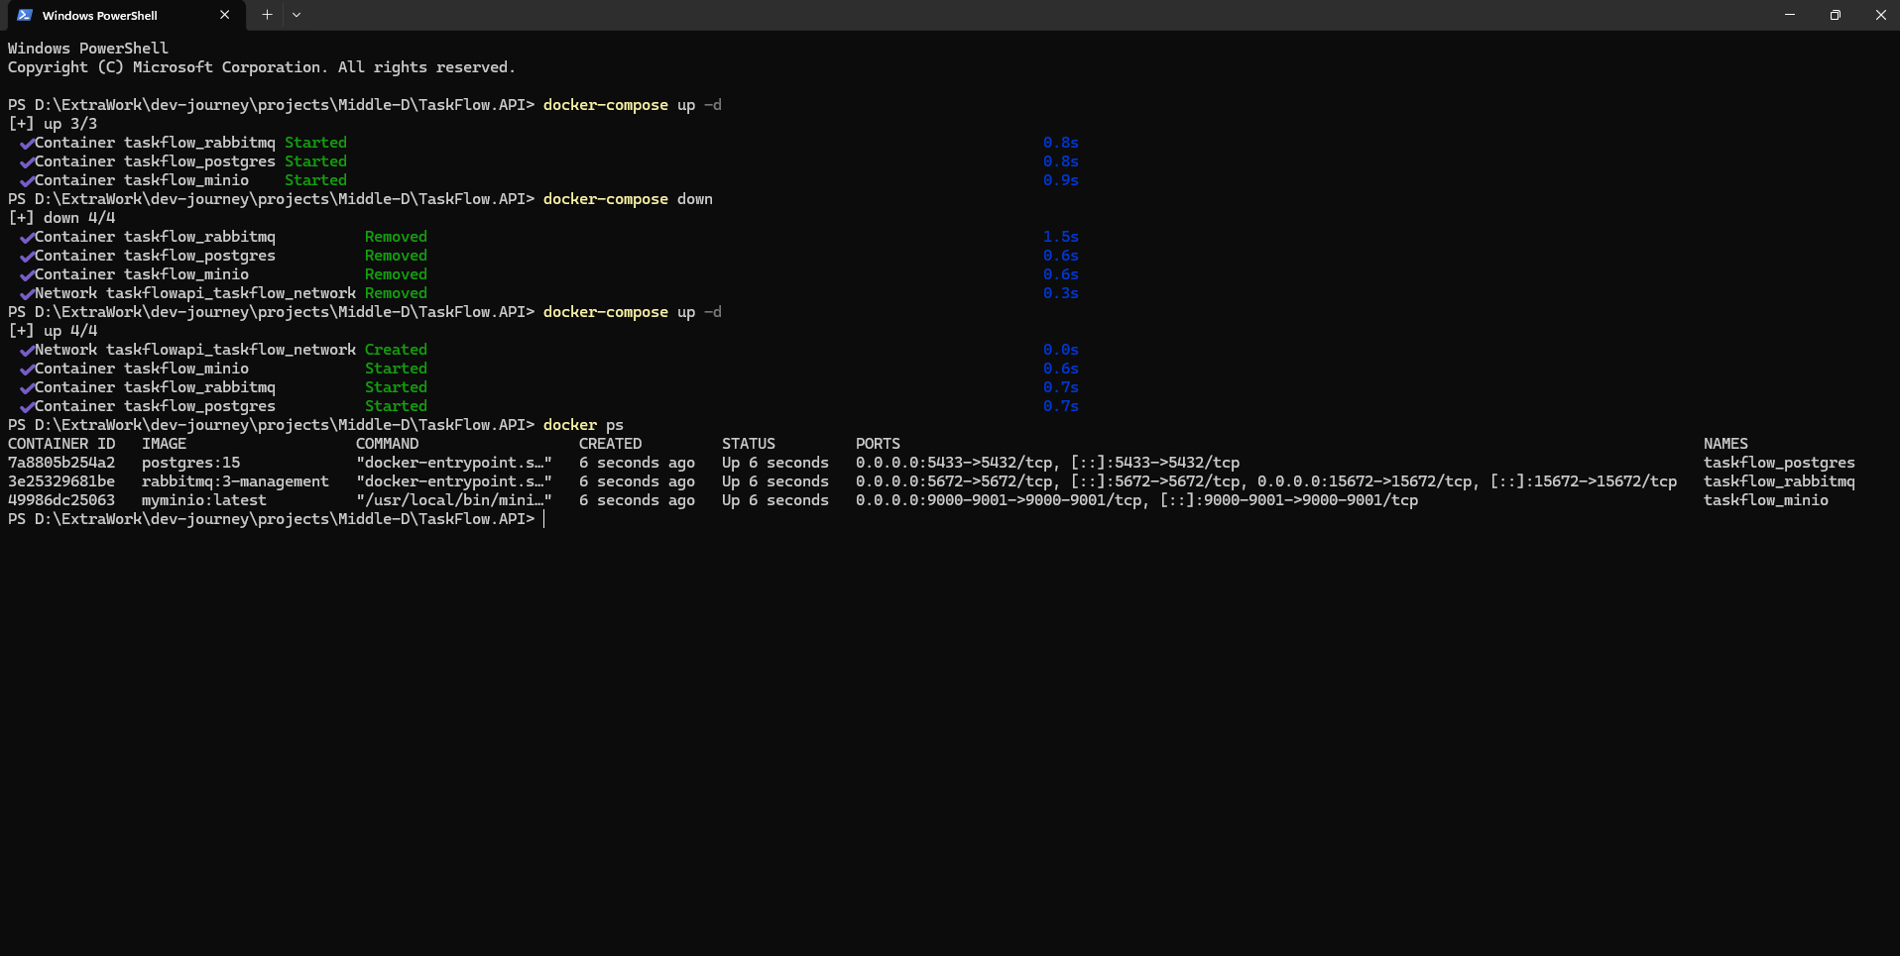Ishga tushirilgan servislar:
Servis | Manzil | Login
PostgreSQL | localhost:5433 | taskflow_user / taskflow_pass
RabbitMQ Management UI | http://localhost:15672 | taskflow_user / taskflow_pass
MinIO Console | http://localhost:9001 | taskflow_user / taskflow_pass123
MinIO S3 API | http://localhost:9000 | —

6. O'rganilgan Asosiy Darslar

Docker haqida
- Docker image lari tashqi registry larga bog'liq — kompaniya istalgan vaqt o'zgartirishi mumkin. Production uchun private registry yoki image versiyalarini pin qilish tavsiya etiladi.
- docker volume rm buyrug'i volume ichidagi barcha ma'lumotlarni o'chiradi — ehtiyotkorlik bilan ishlatish kerak.
- docker logs <container_name> — muammo chiqganda birinchi qaraladigan joy.

Go haqida
- Go cross-compilation uchun GOOS va GOARCH environment variable larini o'rnatish kifoya — boshqa hech qanday sozlama kerak emas.
- Go ning bu xususiyati CI/CD pipeline larda juda qimmatli: Linux serverlar uchun Mac yoki Windows mashinalarda binary yasash mumkin.

MinIO haqida
- MinIO Community Edition 2026-yilda arxivlandi — endi yangi versiyalar chiqishi haqida yangilik yo'q.
- Yangi loyihalarda MinIO o'rniga SeaweedFS yoki Garage kabi alternativalarni ko'rib chiqish mumkin.
- MINIO_VOLUMES environment variable ni aniq ko'rsatish — single-node development muhiti uchun zarur.
- Erasure Coding — ma'lumotlar xavfsizligi uchun production da foydali, lekin kamida 4 disk talab qiladi.

Umumiy
- Muammo chiqganda avval docker logs ni tekshirish — xatolik xabari ko'pincha aniq yechimni ko'rsatadi.
- Open source loyihalarning Dockerfile lari ham eskirishi mumkin — har doim ishonch bilan ishlatib bo'lmaydi.
- Development muhitida tez harakat qilish uchun docker-compose down && docker-compose up -d — eng ko'p ishlatiladigan buyruq.

